Task list of DMS

1. Duplicate should be check for all team and department (done)
2. All validation should be JQuery or React (done)
3. Numeric should be check on all forms and fields(Done)
4. First letter of Name should be as capital letter and also insteam of username it should be as First Name and Last name as per below form and it should be global as well. (done)

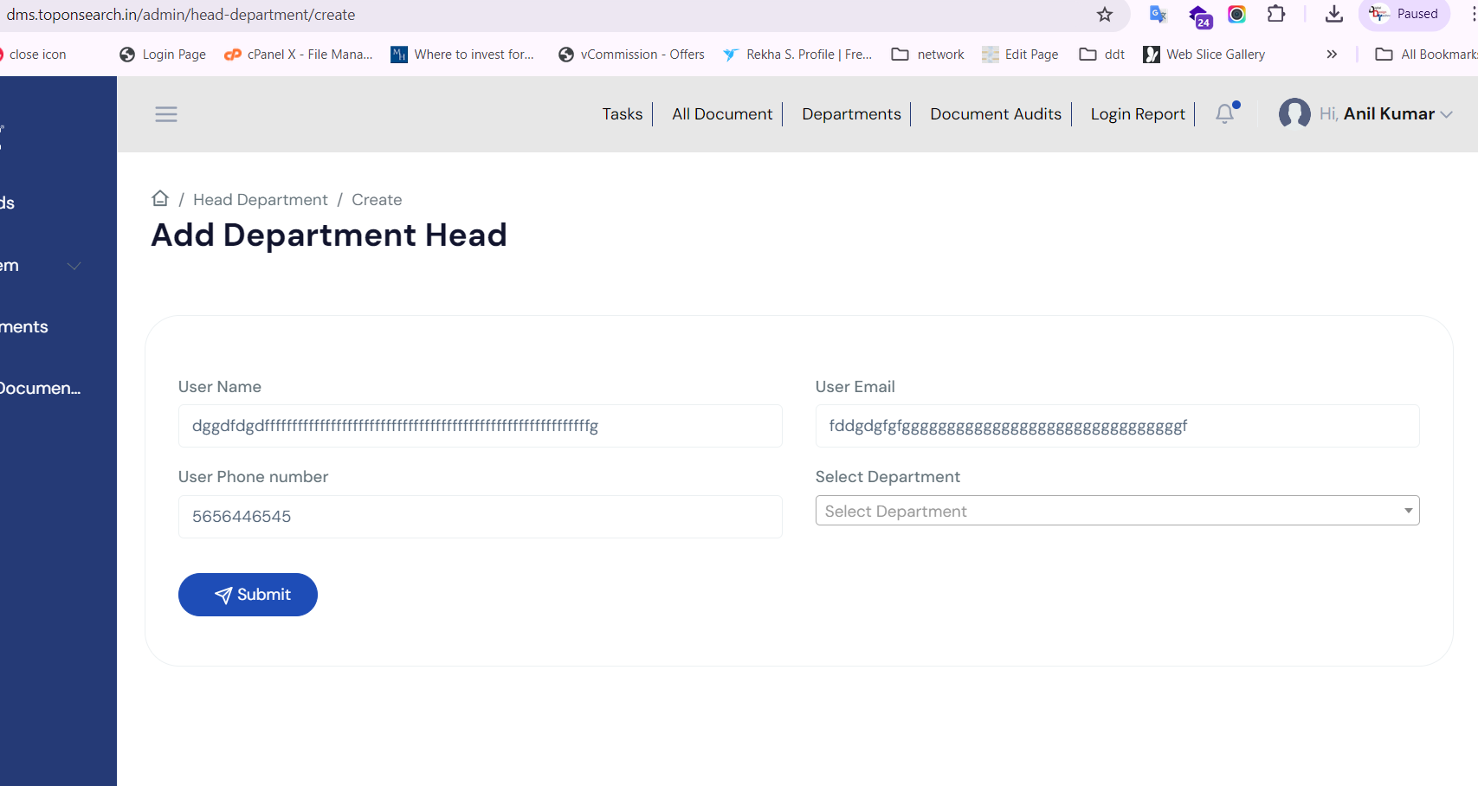

1. While creating Unit Phone no and email with department head option is not required in user it should be as First name and last name. (done)
2. 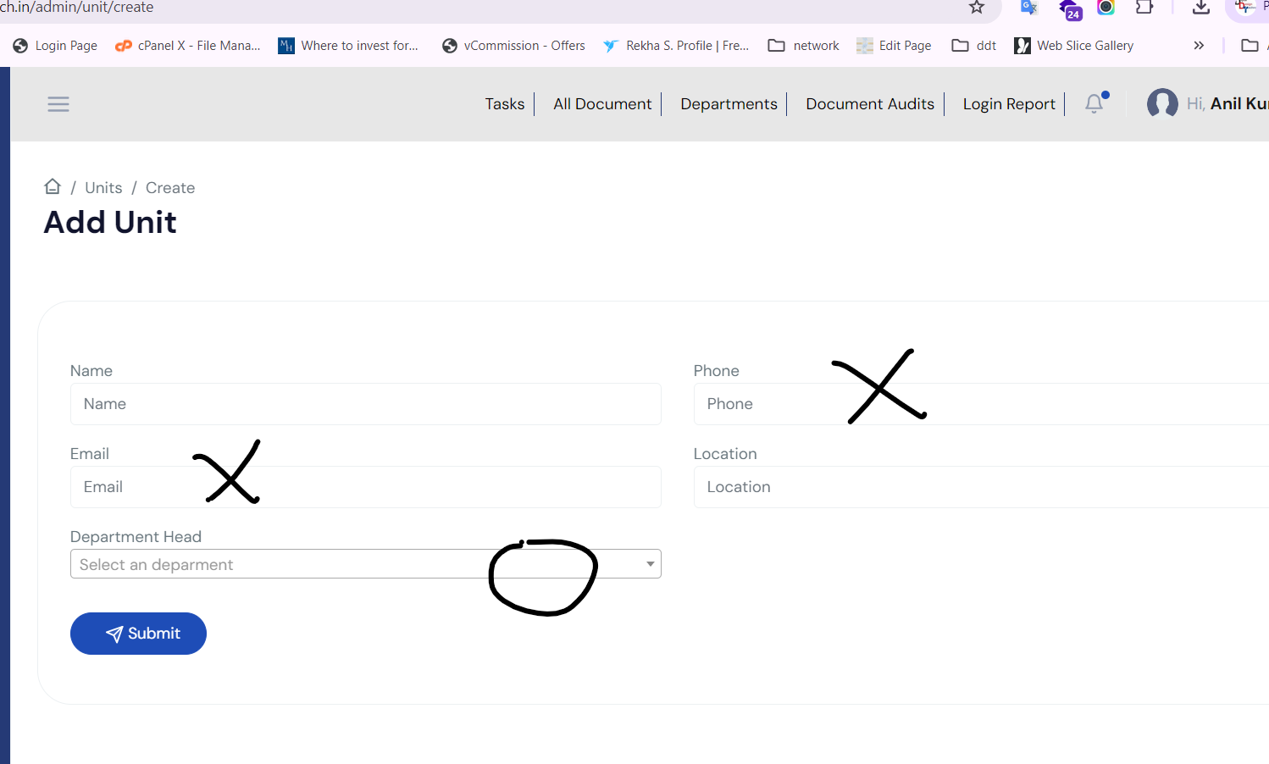
3. In list report data will display order by name only--------
4. For user creation it should simple like designation, department , Unite (it will count as Gurgaon office) and reporting Manager (done) testing pending
5. In login page remember me and password change should be work and we don’t required Signup page so please remove the link (done)
6. 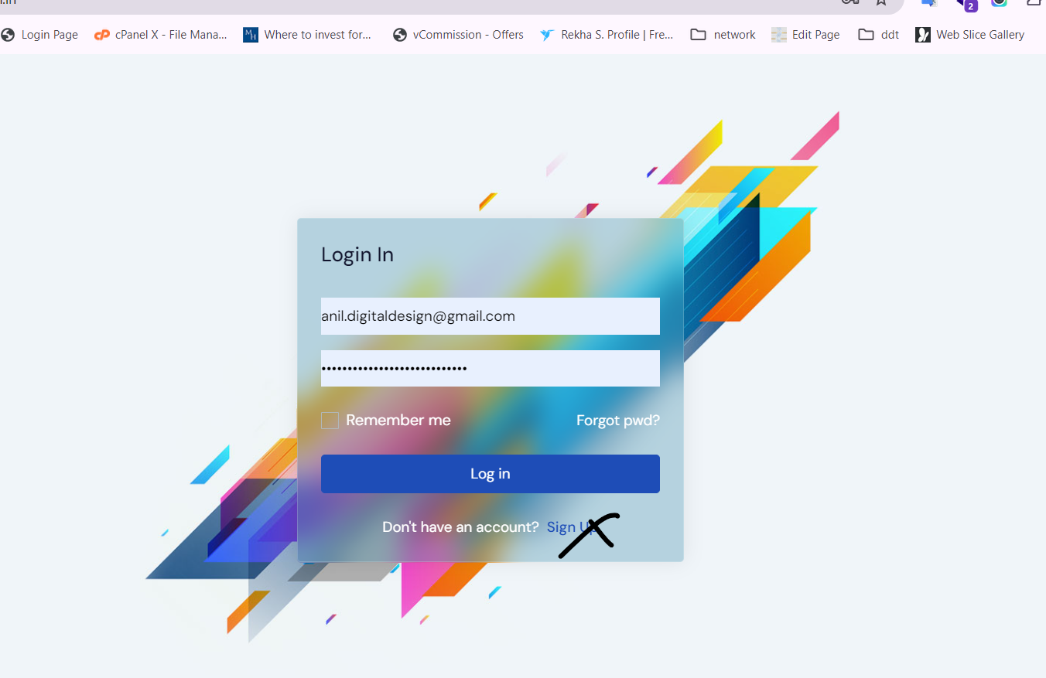
7. In dashboard if document is not shared as recent then message will popup as “No Recent data available” (done)
8. While creating any new folder the name of folder will not be more that 30 words(done)
9. While login on application if password is not correct then message should be display as Wrong password(done)
10. 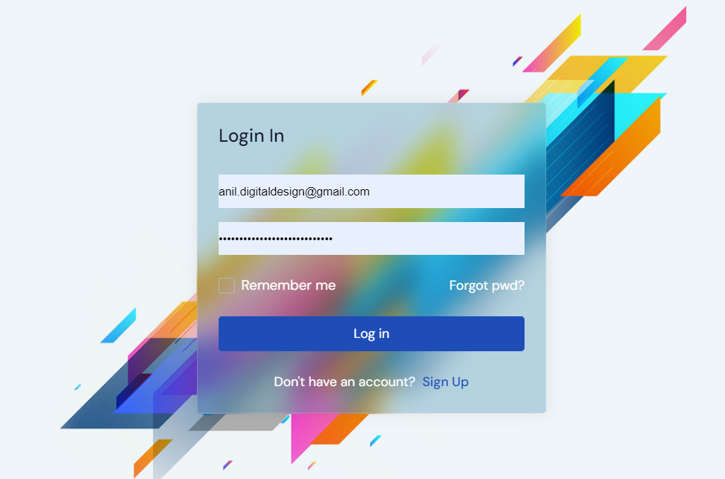
11. Passw ord should be generate automatically for all modules (done)
12. Active and inactive functionality should be in all modules.(Done)
13. List of Active and inactive hotels, users, department should be visible in Admin panel only.
14. After creation of users or giving any access on document or folder email alerts will goes to users as well(Done)
15. Once the permission will be provide on documents and folder the popup message will come on that screen.(Done)
16. Pie chart should be display as per department it is already working but we need to test thoroughly.
17. In users edit email id should be non-editable.(done)
18. Need to design a error page(Done).
19. dms_1.png - You can see, I have been able to add users with special characters in name fields. While adding a user, I was able to add 2 people as Deaprtment***Head***in ***same unit*** and ***same department.***I hadchosen ***BL Park***as Unit and ***Jaipur***as the location, and ***Administration*** as the department.(Done)
20. 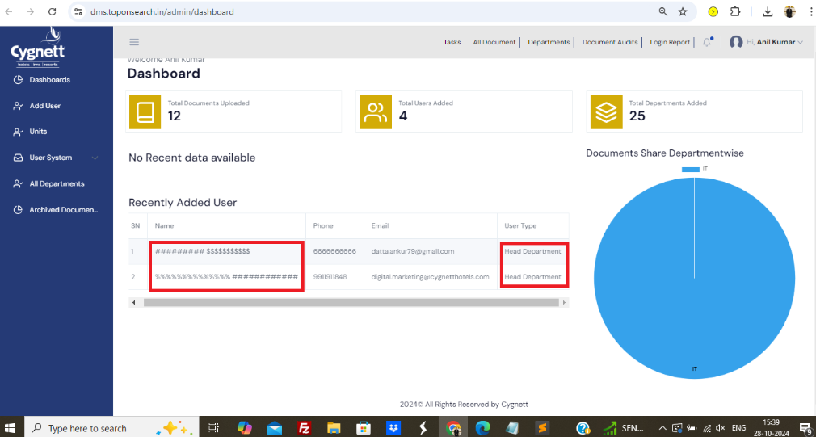
21. dms_2.png - ***Multiple insatances*** of same unit name in same location. Secondly, location should be a ***master*** as well.(Done)
22. 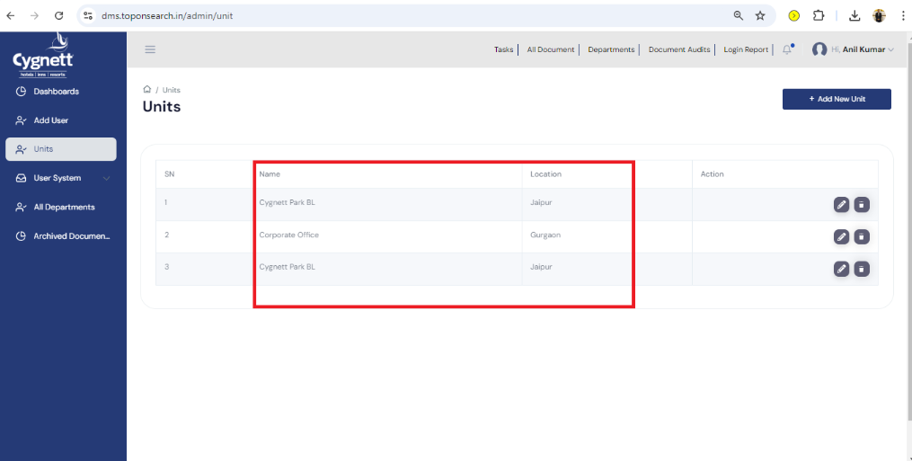
23. dms_3.png - ***Multiple documents*** with same title.Moreover, the system is allowing to upload any type of files. I have been able to upload php and js files. A DMS should only allow documents like doc/xls/pdf/ppt/txt. [@Sachin Gaur](mailto:sachin.gaur@cygnetthotels.com) , [@Hem chandra](mailto:hem.chandra@cygnetthotels.com) , [@Sugata De](mailto:sugata.de@cygnetthotels.com)  - please share your thoughts on this.(Done)
24. 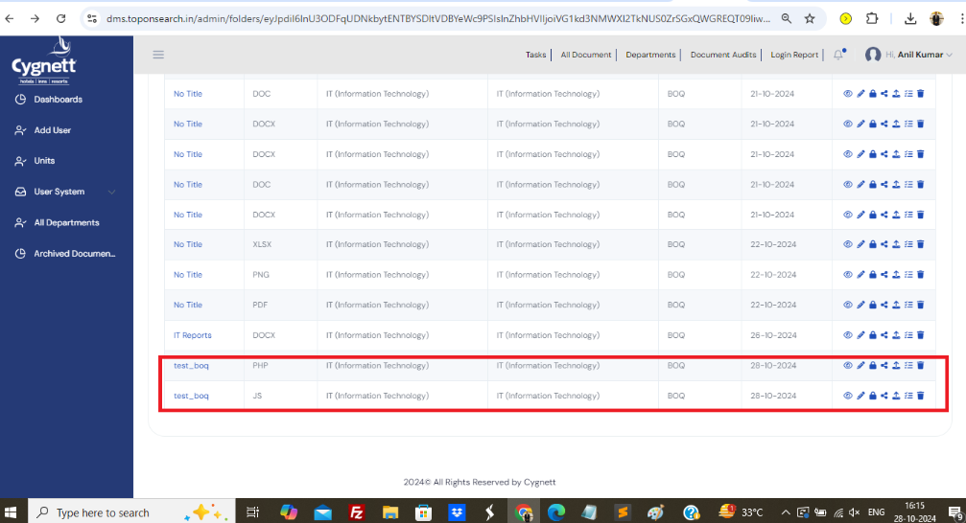
25. dms_4.png - Similar named department can be added multiple times.(Done)
26. 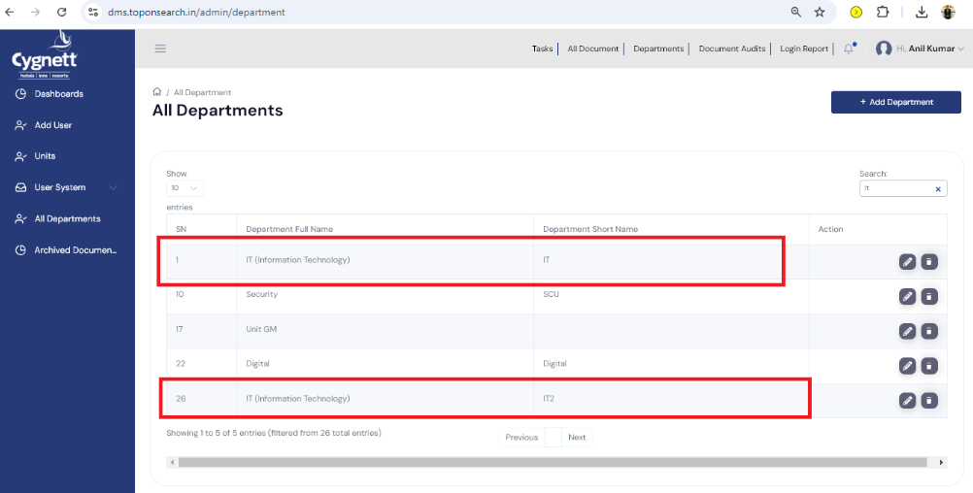
27. From my observations, pagination typically has been implemented using the data-table feature. While this method is effective for smaller datasets, our data is expected to grow significantly. Therefore, to ensure robust and flexible searches, we need to implement custom server-side pagination(Done)
28. Listing of data should be in descending order(Done)
29. Name should be always alphabate and as per screenshot it is taking even special character also.(Done)  
    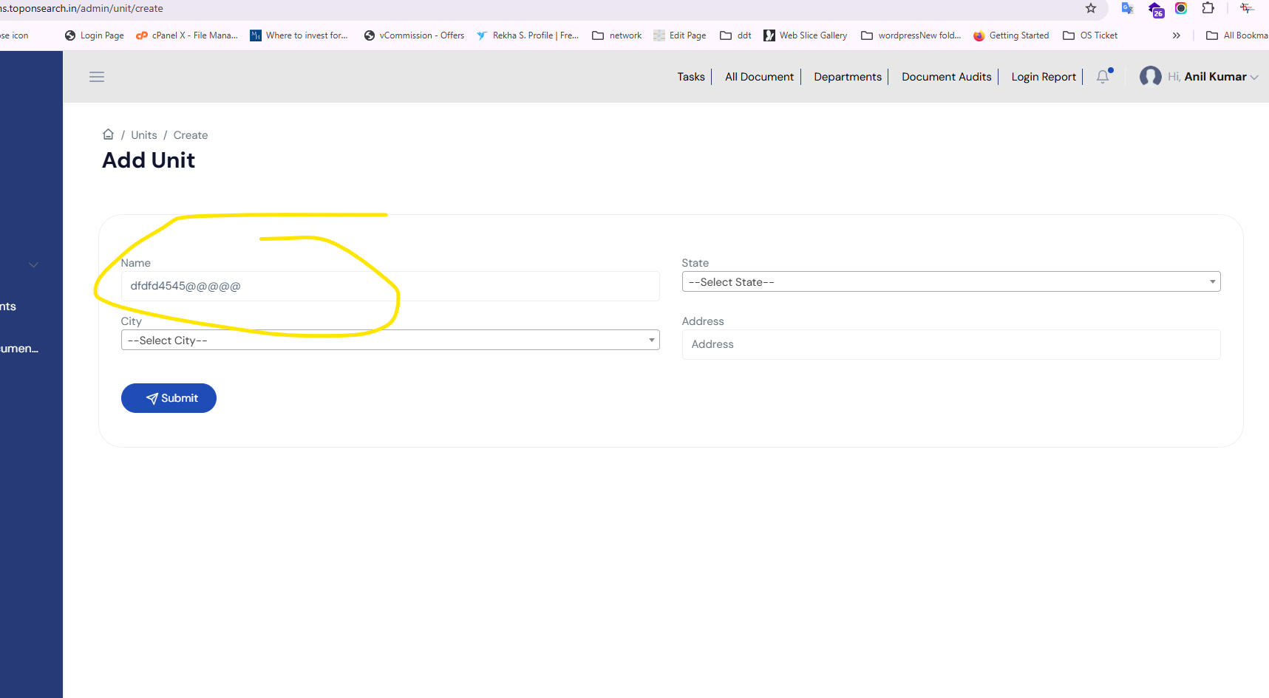
30. While adding unit as Chandigarh city should be Chandigarh as currently is showing blank city (Done).  
    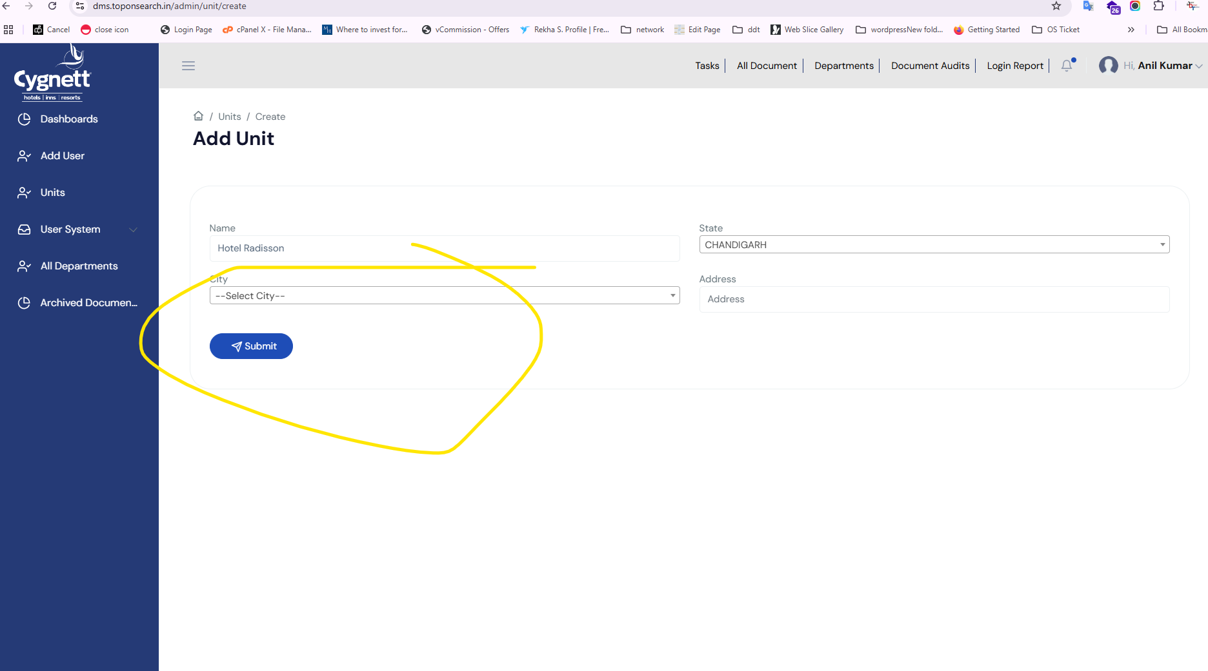
31. Duplicate name (Done)  
    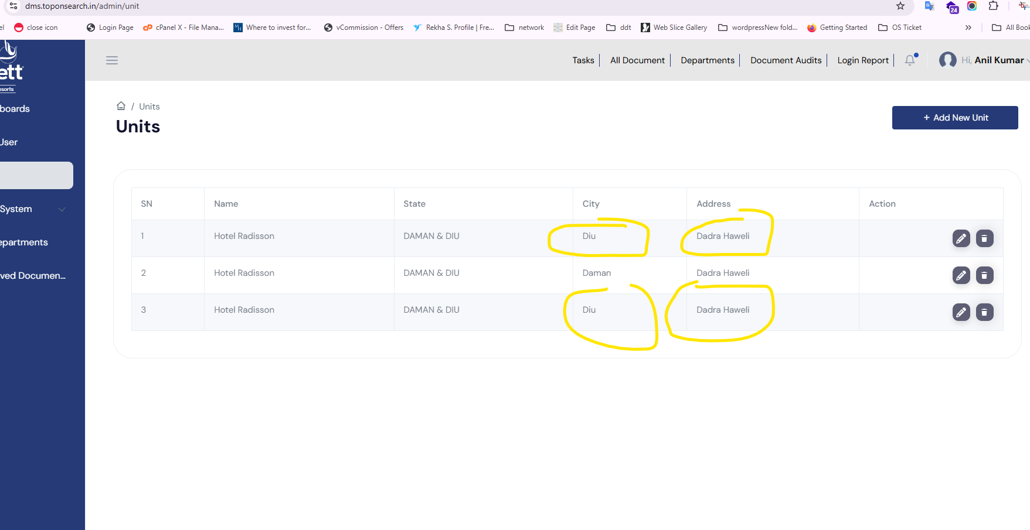
32. While adding manage under corporate head it is showing error as per screenshot(Done)  
      
    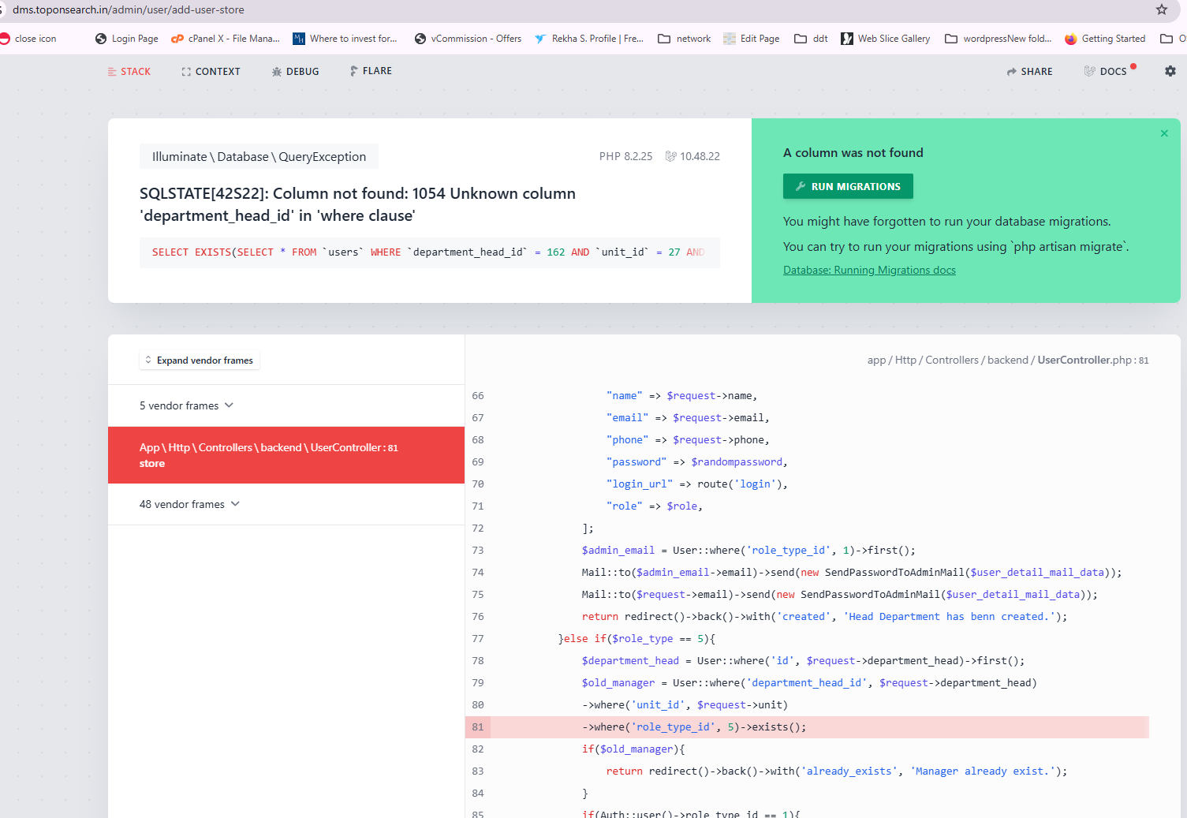
33. Email templates for new users should be enhanced as per below screenshot(Done)  
    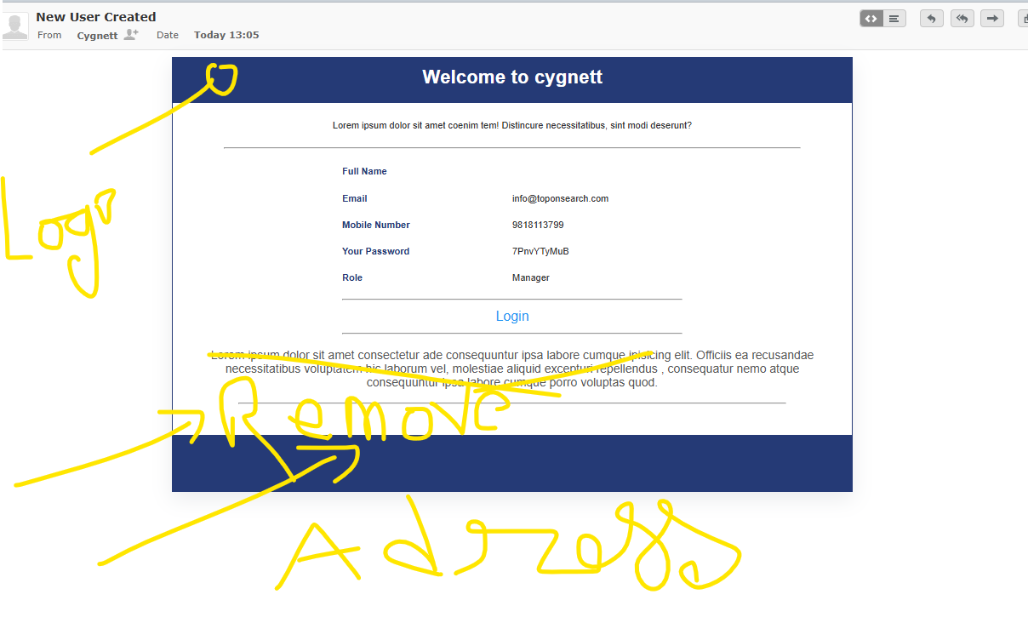
34. Added one user as Divyang Mehta in Hemchandra login but tt is now showing(Done)
35. Kindly add text area while creating task(Done)  
    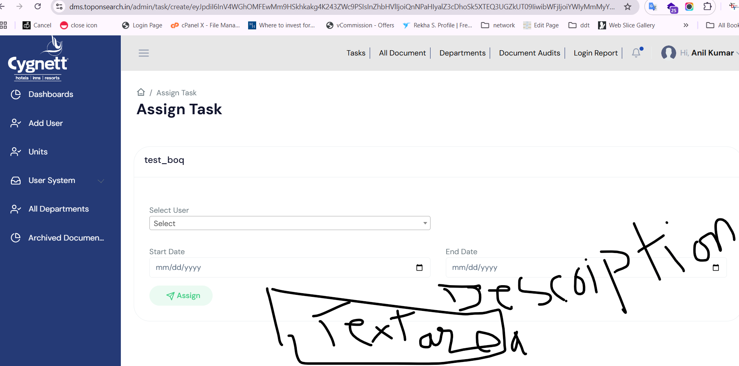
36. In all report date with time stamp should be necessary(Done)   
    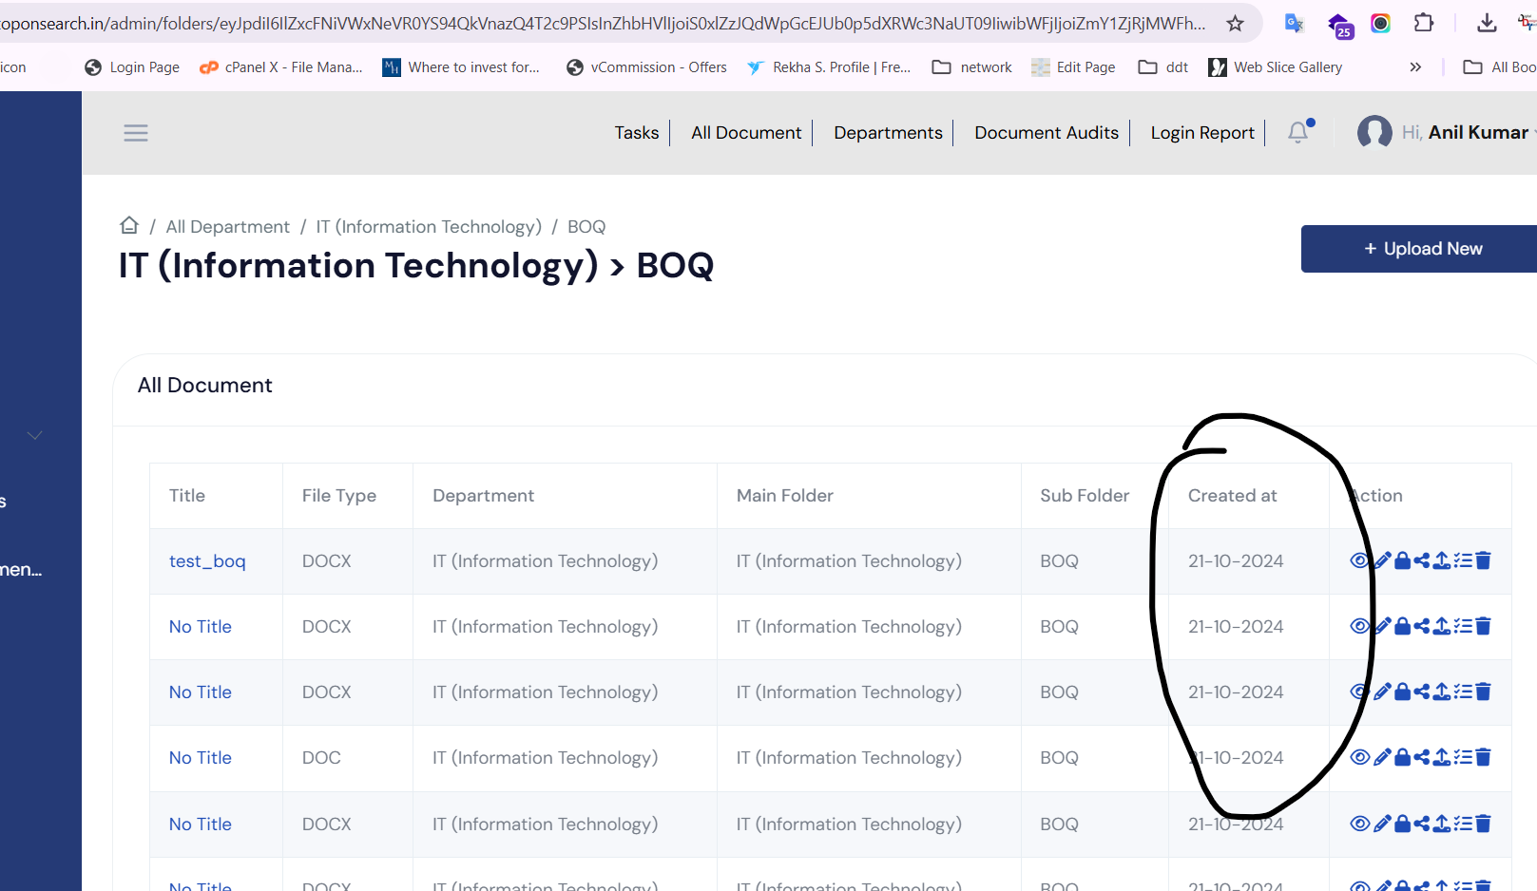  
    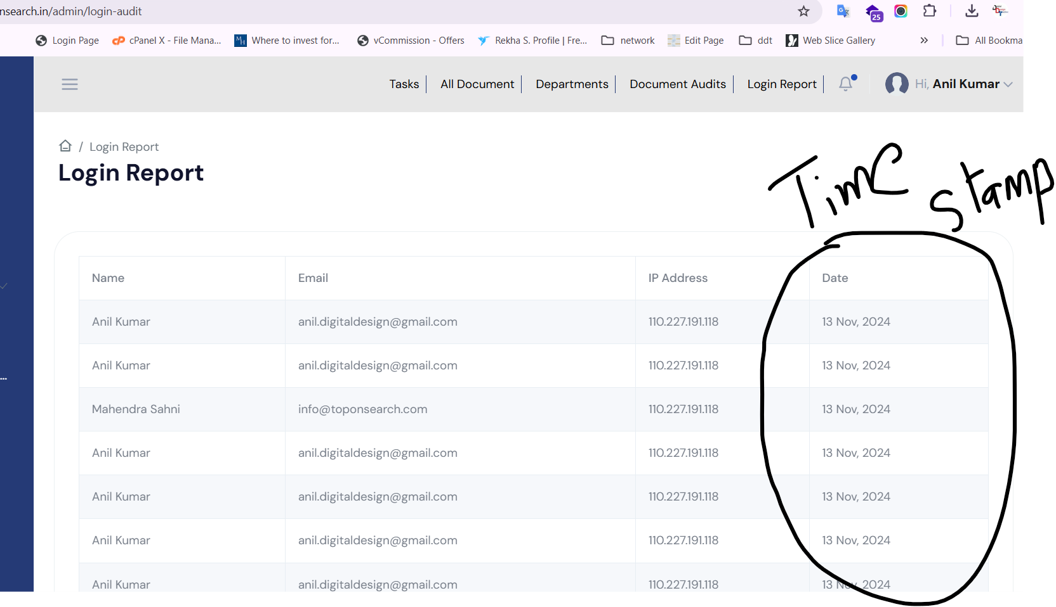  
    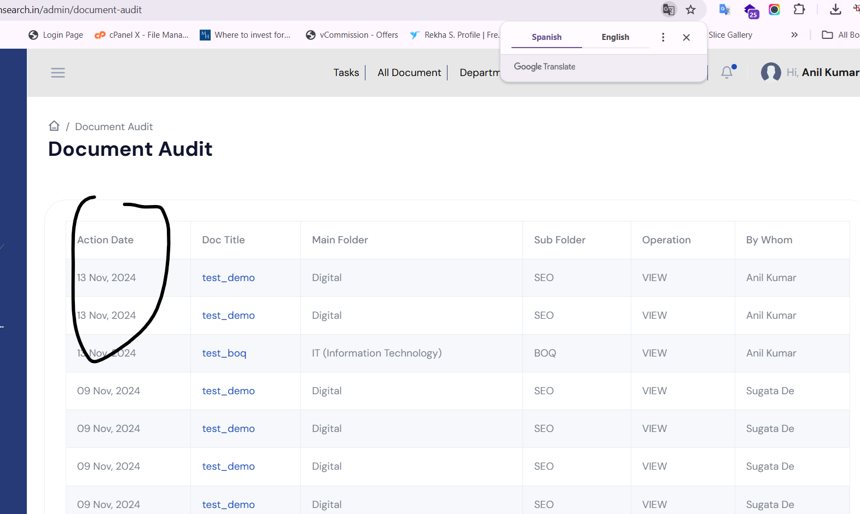
37. In task page create task button should be there (Done)  
    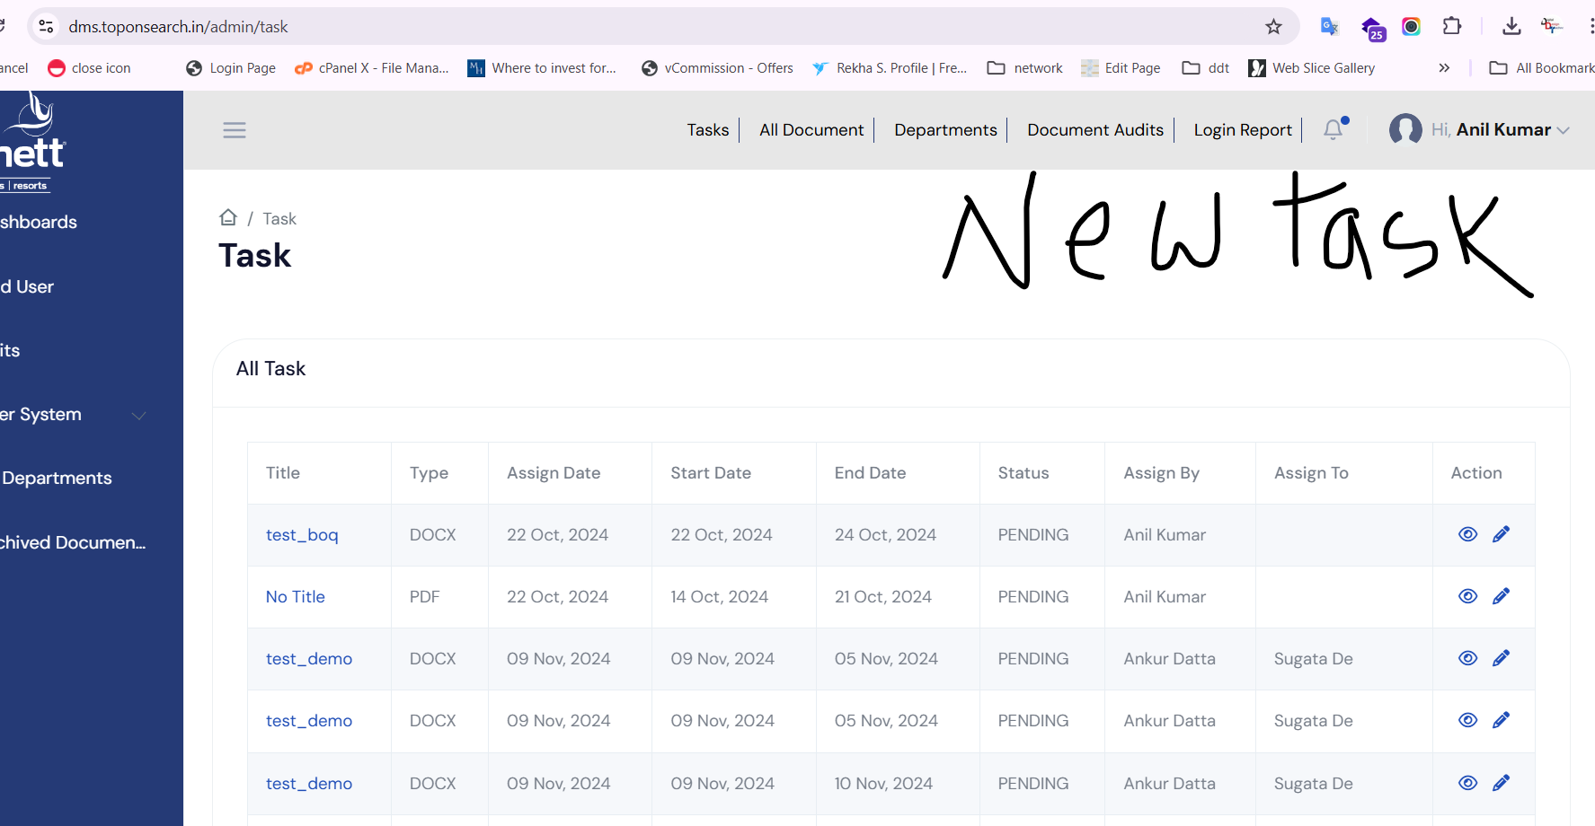
38. In folder page it should be show alphabetically(Done)  
    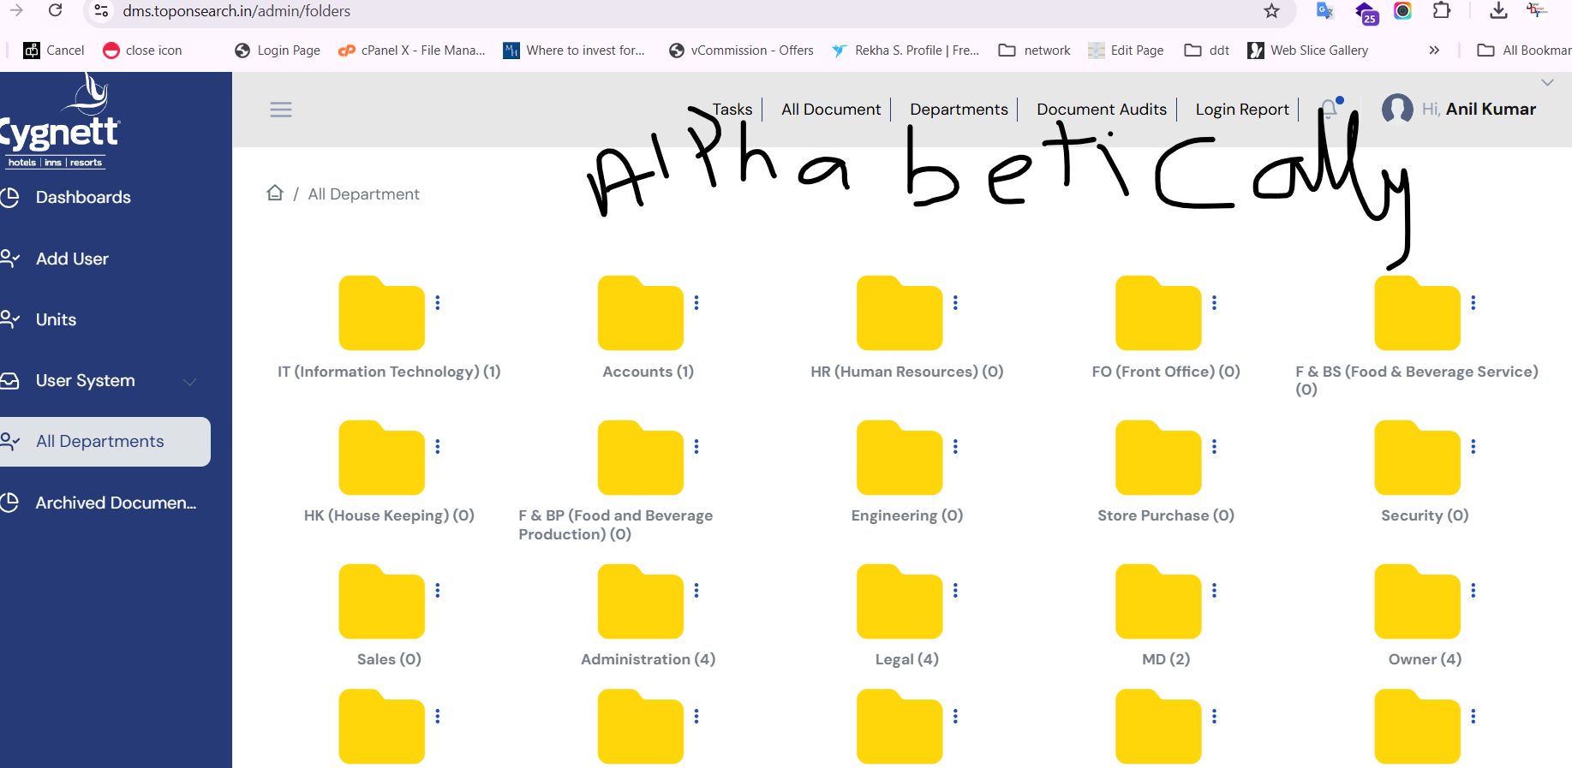
39. In document file all should be populate as hower if I go to edit then edit hower should be popoulate(Done)  
    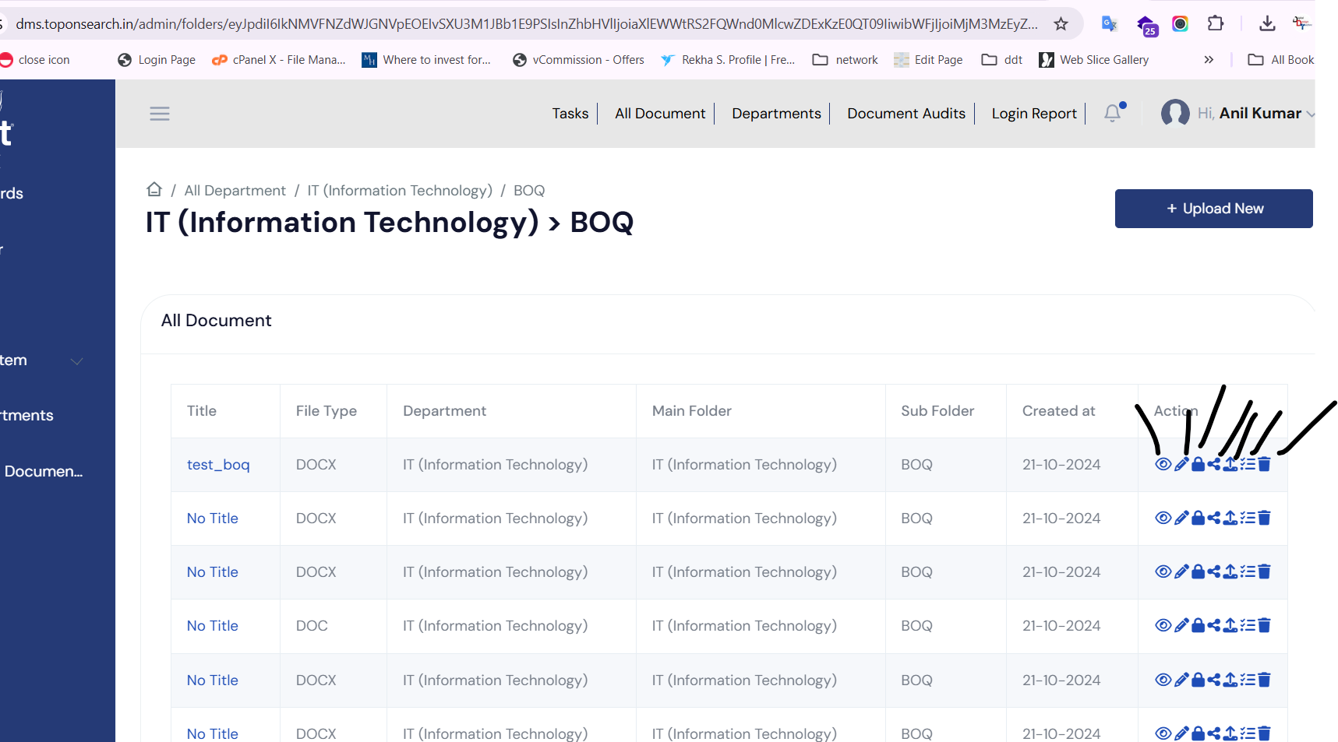
40. While file uploading ji it should be msoffice file like .docx, .xlsx, pptx, jpg, gif,pdf,png only rest file extension should be block.(Done)
41. File size not exceed 500 MB(Done)
42. After checking duplicate in adding Unit and after giving warning popups data goes to blank so the form should be filled out with red color on duplicate(Done)  
    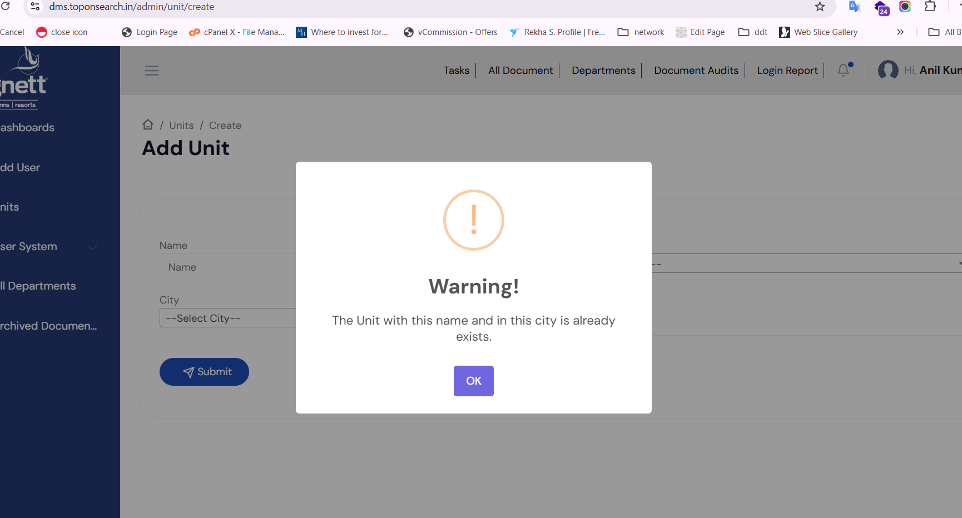
43. While assigning task description is not showing in email as per below screenshot(Done)  
    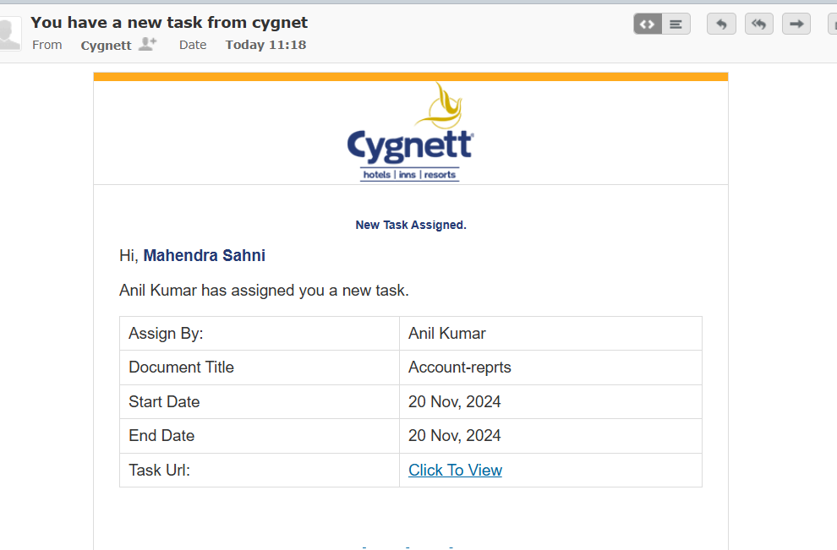
44. As per below screenshot file location should be proper as per rest of the pages for folder.(Done)  
    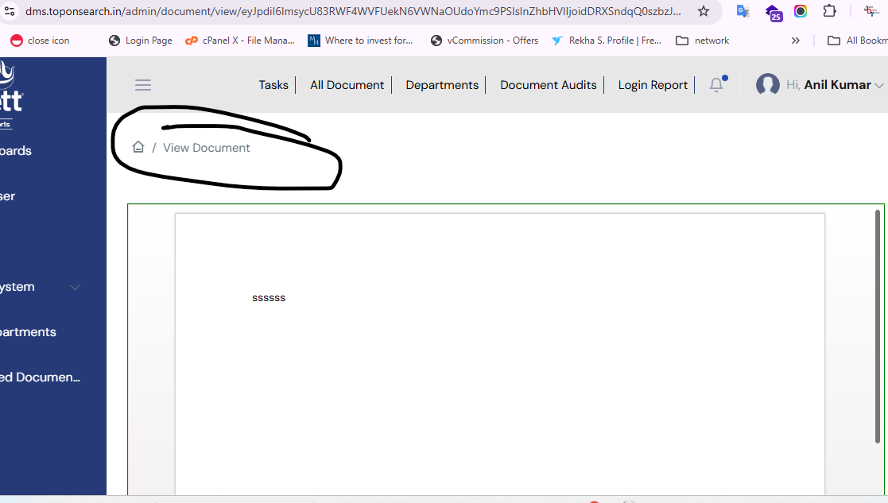
45. Please check the validation of date as it is accepting prior dates.(Done)  
    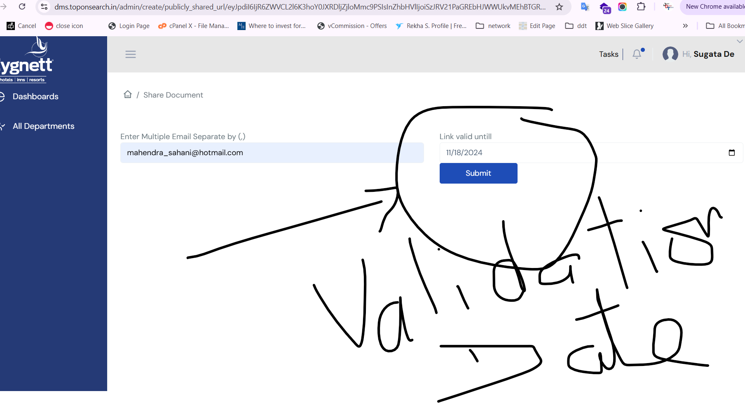
46. In permission page the above link is not working as per below screenshot(Done)  
    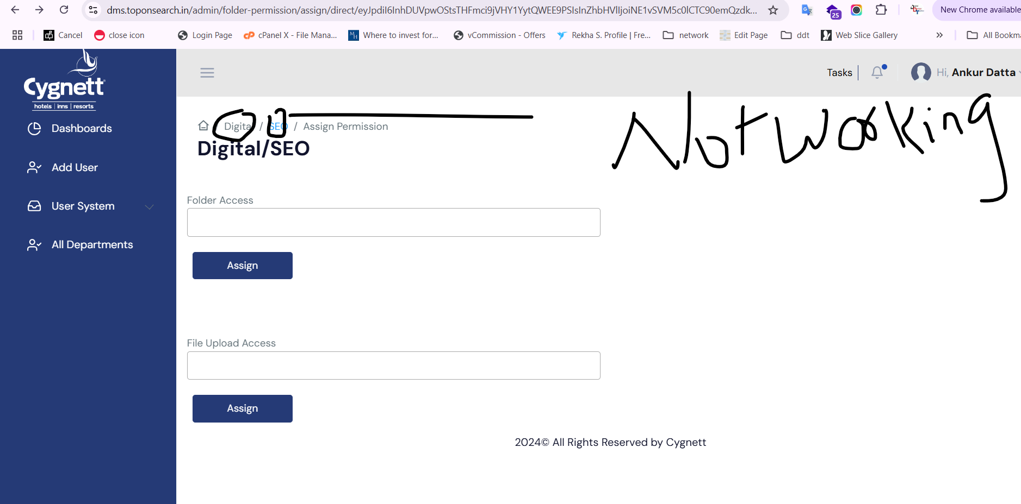
47. As per below screenshot I have given rights to Sugata for folder access but he have option to upload the file as well which is not available the rights(Done)  
    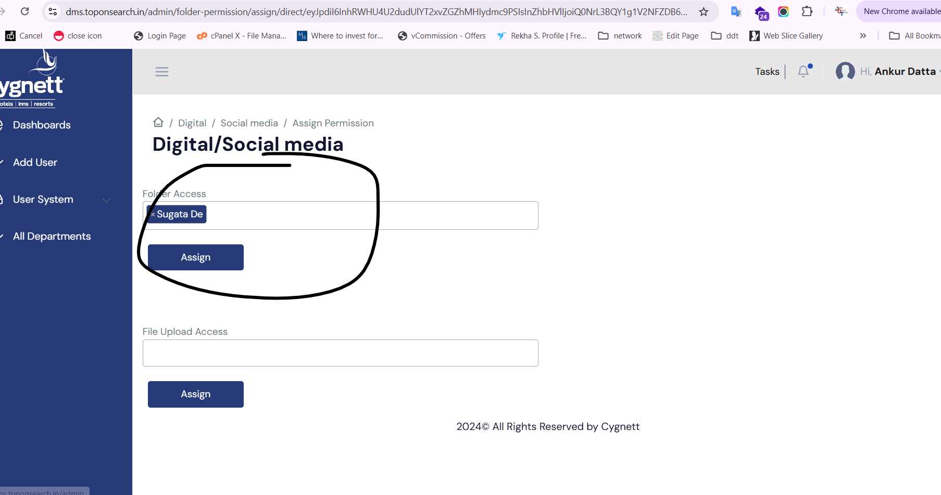51) As per below screenshot shot sugata having rights and he can upload the file (Done)  
    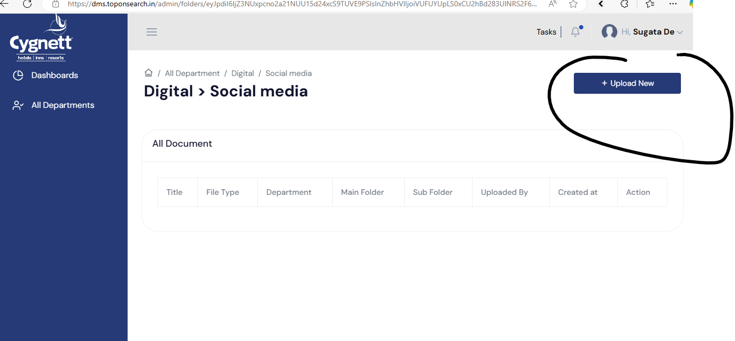  
    52) please allow cross department as well so if the has been allowed to read the document so he can see the document in the folder.(Done)  
      
    as per below screenshot he should have access to see the file in that particular folder.(Done)

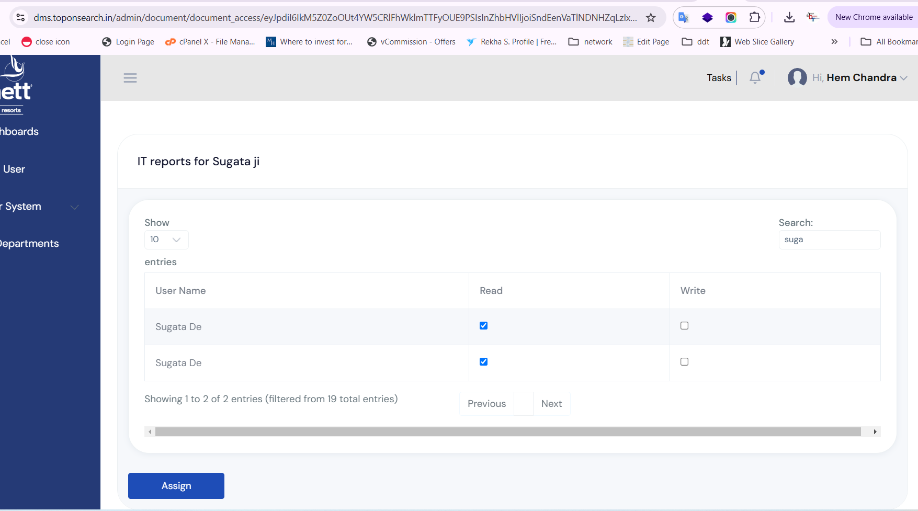

1. As per screenshot not able to provide rights on team members.(Done)  
   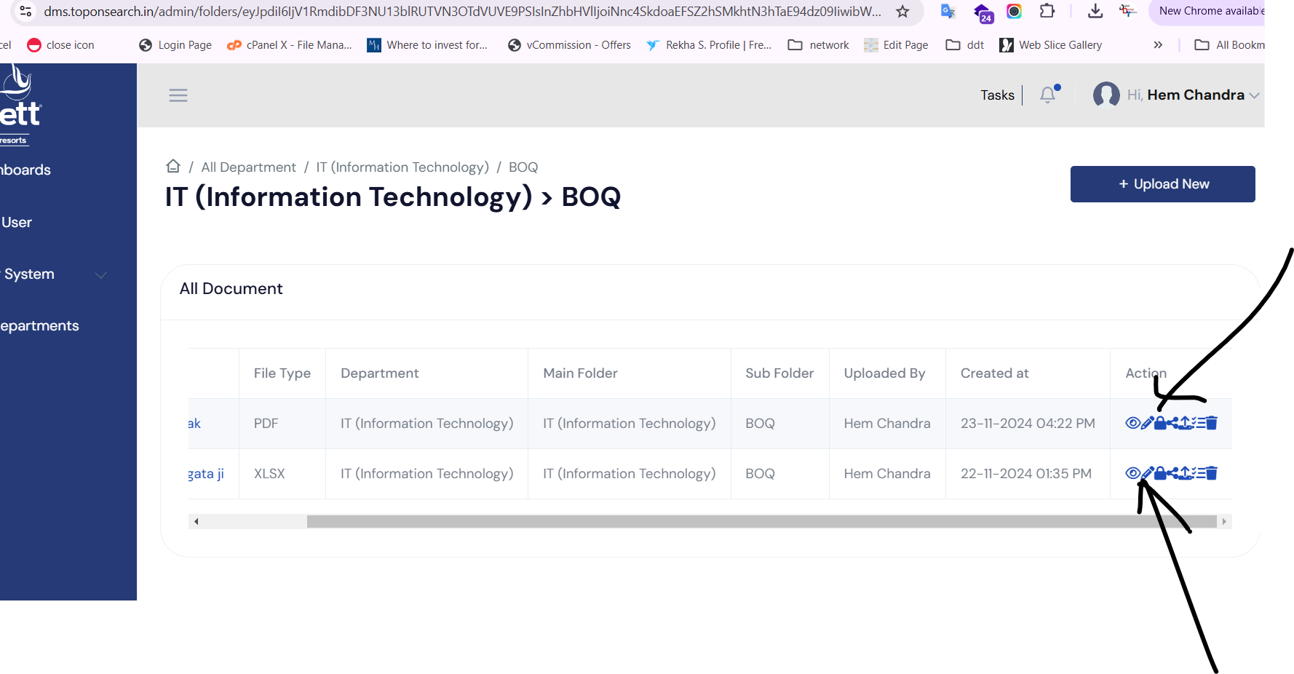  
   please see users Deepak who is not able to see the file after given permission.(Done)  
   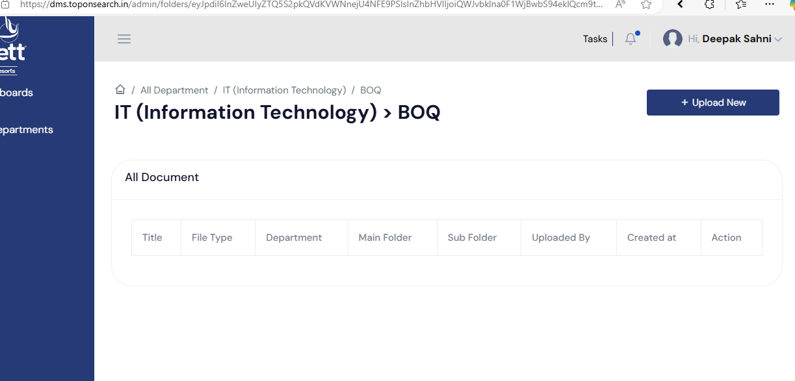
2. Please see the below screen as digital marketing Ankur data digital marketing he is sharing file but Deepak is not able to see the document.(Done)  
   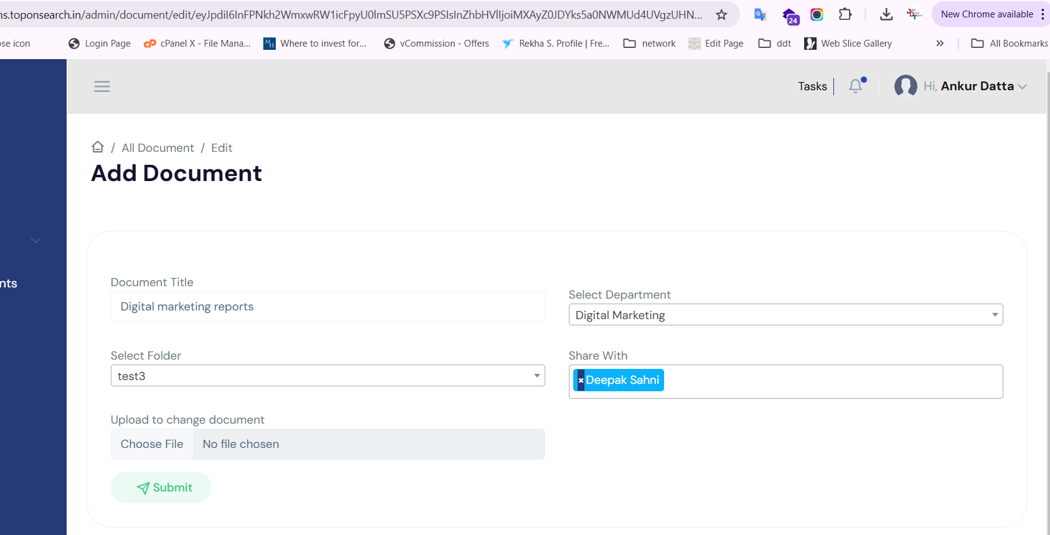
3. Link is not working as per screenshot it happening every time(Done)  
   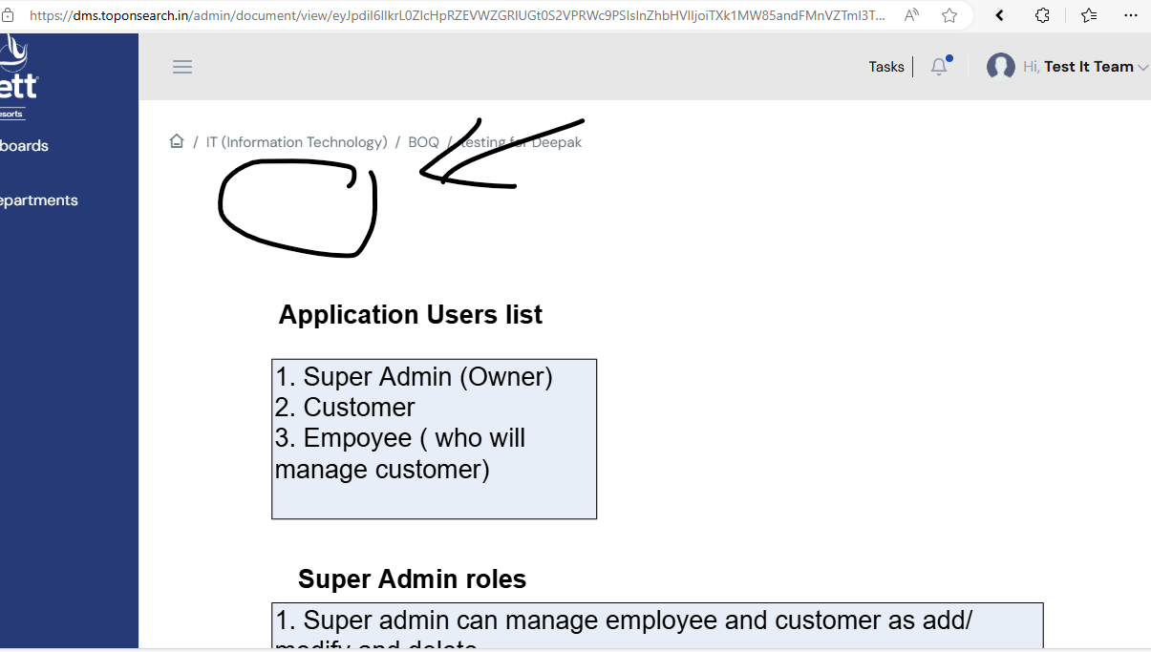
4. Start date can’t be select before current date so please rectify ASAP.(Done)  
   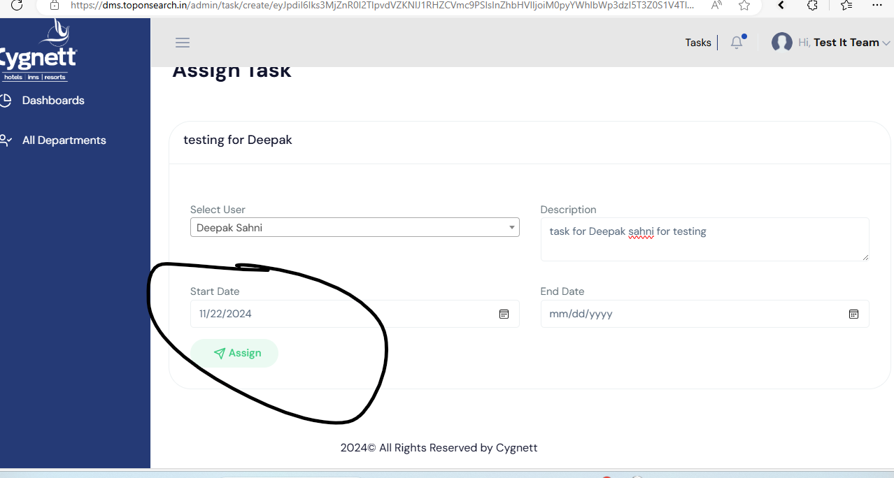
5. End date cant be select beyond start date please resolve this issue as per below screenshot(Done)  
   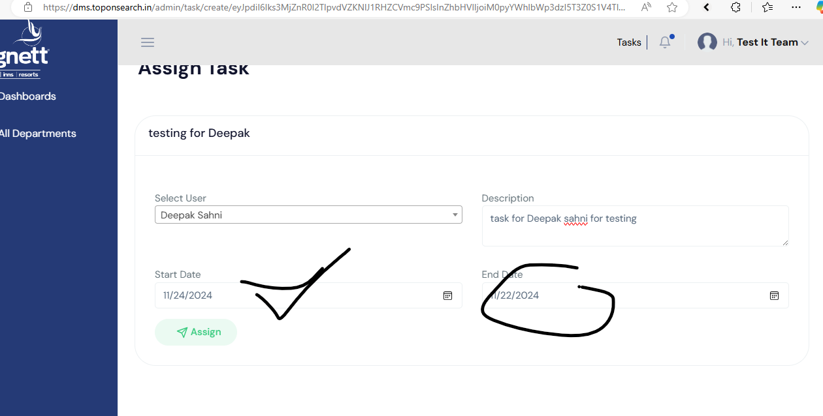
6. While clicking on task it showing error as per below screenshot.(Done)  
   